**NETWORK MODEL OF A COMPANY**

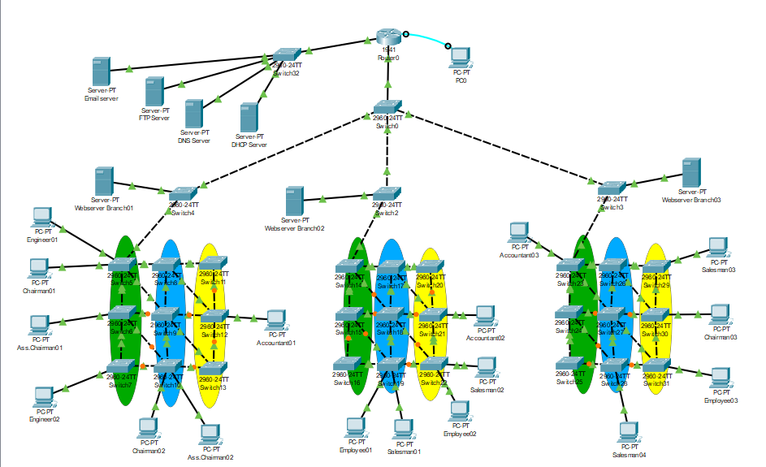

**ABSTRACT:**

In today's world, Networking have become extremely necessary for providing e-mail, telnet, chat and others services. In these services, computer networks play very important role to communicate, administrate, automate and process the information from point to another points. Hence Computer networks considered the basics of proper functionally in most of the companies and organizations. In this paper, cisco packet tracer is used as a network simulator tools to simulate and design a network project of company. The paper discussed interconnection between routers, switches and other components in data communication network and how are programmed and configured.

**PRIOR HISTORY:**

Total ten days were required to complete this project. Me and my group partner Abdul Bari made this project at my place. There were many situations when we want to add a thing and because of that we had change the whole project from the start. By the collaboration of both brains we finally came up with this project which is I think is not bad.

**DESCRIPTION OF THE PROJECT WORK:**

**INTRODUCTION:**

Computer network can be defined as a number of computer systems and other computing hardware devices that linked together for sharing information in form massage, files, data bases in organization that may be in one building or spread over large campus. In addition to that the networks decrease cost, time, effort and thereby increase productivity. Network connections devices are connected together by using any type of communication media such as the copper coaxial cable, twisted pair cable, fibre optic cable and wireless. While the network devices include Network interface cards (NIC), Hubs, Switches, Bridges, Routers, Gateways and Modems. Each one of these devices has various properties than others from jobbing, security and application.

This paper is highlighted on the VLANs (Virtual Local Area Network). VLAN is simply a subset of switch ports that are formed to be in the same broadcast domain. Switch ports can be assembled into different VLANs on a single switch and on multiple interconnected switches as well. By creating multiple VLANs, the switches create multiple broadcast domains.

Cisco Packet Tracer (CPT) is a multi-tasking network simulation software that can be used to perform and analyse various network activities such as implementation of different topologies, selection of optimum path based on various routing algorithms, creation of appropriate servers, sub netting, and analysis of various network configuration and troubleshooting commands.

**AIMS AND OBJECTIVES:**

The aims of this project is totally developed our skills how to create a company network .due to this project we learn many things such as how to deal with servers and how to upload a file on a server and many things we learn and hope INSHAALLAH this will help in our future

**TECHNIQUES USED:**

1. Mesh Topology
2. (Variable Length Subnet Masking) sub netting
3. Dynamic Host Configuration Protocol
4. (Domain Name Server) Configuration
5. File Transfer Protocol
6. Telnet
7. Web Server
8. Email Server

**RESULTS:**

Here we used mesh topology so that we stay connected even if one node is down which is very important in a big company. Variable Length Subnet Masking is used so that no Internet Protocols Addresses are not wasted. These Internet Protocol Addresses are assigned by Dynamic Host Configuration Protocol. There is a server for File Transfer Protocol from where any user can download or put important documents on the server which is necessary to work fastly and efficiently. There is a server called Domain Name Server which will direct the computers to the desired server. Telnet is also implemented to configure the router from the computer. While there are servers for websites and emails.

**CONCLUSION:**

The packet tracer is used to implement the network of the project and clarity the conception of the VLANs, DHCP, website server and router configurations. Networking devices are expensive so the packet tracer is easy and best to implement structure of the network before implementing it on the real ground. Also in the paper, the VLANs provide the security, broadcast control and physical layer transparency.